Floor bannink

Nanoscience and Nanotechnology Summary

Table of Contents

Introduction to Nanoscience & -technology – Lecture 1 3

Unit Calculation/Conversion 3

Properties of nano particles (Scaling effect) 4

Crystal structures and fundamentals – Lecture 2 6

Cleanrooms 6

Silicon Wafer 7

Crystal Structure 7

Crystal Systems 8

Planar density (PD) 10

Summary coordination number, atoms/cell, APF, radius 11

Fundamentals of nanomaterials – Tutorial 1 12

Crystal structures and fundamentals - Lecture 3 13

Silicon/diamond unit cell 13

Symmetry in crystals 14

Crystal defects 14

Quantum effects in nanomaterials – Tutorial 2 15

Electron confinement 15

Particle in the box 15

From sand 2 silicon monocrystalline wafers + wafer yield – Lecture 4 17

Silicon wafer manufacturing – 4 main steps 17

Yield calculation 18

Oxidation and Lithography – Lecture 6 19

Thermal Oxidation 19

Dry Oxidation 19

Wet Oxidation 19

Photoresists and Lithography 20

MIDTERM CONTENT UNTIL HERE (2021) 21

Spin Coating – Process to form thing films of PR on Si wafer 22

Soft bake 22

Hard Bake 22

Mask 22

Silicon Anisotropic Wet Etching - Tutorial 5 25

Anisotropic wet etching – Silicon 25

Etching – Lecture 8 26

Wet etching 26

Exercises 28

Miller indices 28

Yield calculation 28

Cantilever production process flow methods 30

Bulk micro machining 30

Bulk surface machining - SiO2 anchor, Poly Si cantilever 31

Bulk surface machining – Poly Si anchor and cantilever 32

Bulk micro machining – Silicon on Insulator (SOI) cantilever 34

# Introduction to Nanoscience & -technology – Lecture 1

**What is Nanotechnology?**

Nanotechnology involves manipulating matter at unprecedentedly small scales to create new or improved products that can be used in a wide variety of ways.

* Interdisciplinary: Chemistry, Biology, Physics, Engineering, Medicine, Biotech., Material Science, IT

## Unit Calculation/Conversion

1 mm3 = 1018 nm3; 1cm3 = 1000 mm3

* factor of 10 in length is factor of 1000 in volume

Scaling effect example cube:

a1 = 1cm a2 = 1mm

v1 = 1cm^3 = 10^-6m^3

v2 = 1mm^3 = 10^-9m^3

s1 = 6cm^2 = 6 * 10^-4m^2

s2 = 6mm^2 = 6 * 10^-6m^2

v2/v1 = 10^-9/10-6 = 10^-3

s2/s1 = 10^-6/10^-4 = 10^-2

* Volume > Surface Area > Length

## Properties of nano particles (Scaling effect)

Smallness leads to change in: Advantages of Miniaturization:

* Reactivity
* Melting point
* Strength
* Conductivity

In general, smaller things are less effected by **volume** dependent phenomena such as mass and inertia and are more effected by **surface area** dependent phenomena such as contact forces or heat transfer.

**Thermal inertia**: A measure on how fast we can heat or cool a solid. It is an important parameter in the design of a thermally actuated devices.

**Scaling effects on spring constant**

Spring constant proportional to length

**Scaling effects on stress in a rod**

**

**Scaling effects on electrical resistance**

R = eL/A = eL/(pi*r^2)

Resistance proportional to L/r2

**Scaling effects on capacitance**

C = EA/d

Capacitance proportional to length

**Scaling effects on fluid flow**

Re = rho*v*l/mu

-> Reynolds Nr. very small at nano scale, thus only laminar flow (no mixing possible)

# Crystal structures and fundamentals – Lecture 2

## Cleanrooms

A cleanroom is an environment where the **particulate contamination & bacterial contamination** are limited to prescribed levels.

Class 100 (ISO 5) = Max. 100 particles of 0.5-micron

Class 1000 (ISO 6) = Max. 1000 particles of 0.5-micron

**Parameters to be controlled**

Temperature, Humidity, Air Cleanliness, Room Pressure, Air Movement, Lighting

**Costs**

**How is it done?**

* HEPA (high energy particulate air filter)
* Temperature 68-72 °F
* Humidity 40-46% RH
* Positive pressure

## Diagram Description automatically generatedSilicon Wafer

Thickness: 100-500 micrometres

Size: 4-12 inch (steps of 2 inch)

**Advantages Silicon**

**Types:** Single crystal (monocrystalline, ideal); Polycrystalline, Amorphous (non-crystalline)

**Crystalline** = Periodic arrangement of atoms. Periodicity of atoms in crystalline solids can be described by a network of points in space called **lattice**.

**Single crystal** = atomic structure that repeats periodically across whole volume

## Crystal Structure

Angle between crystal planes:

Interplanar distance:



**Miller indices** = Normal direction of planes. Describes with which axis the plane intersects.

Example: (1 0 0) = (h, k, l)

**Note:** a bar above number denotes **negative index $\left(1,\overline{1},1\right)=(1,-1, 1)$**

The space lattice points in a crystal are occupied by atoms. The position of any atom can be described by the vector **r = ua + vb + wc**.

The unit vectors define a cell that is known as **unit cell**.

## Crystal Systems

Remember by heart: drawing, side & angle relations

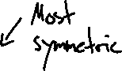

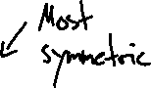

**Coordination number** = number of nearest neighbouring atoms to a particular atom in a crystal

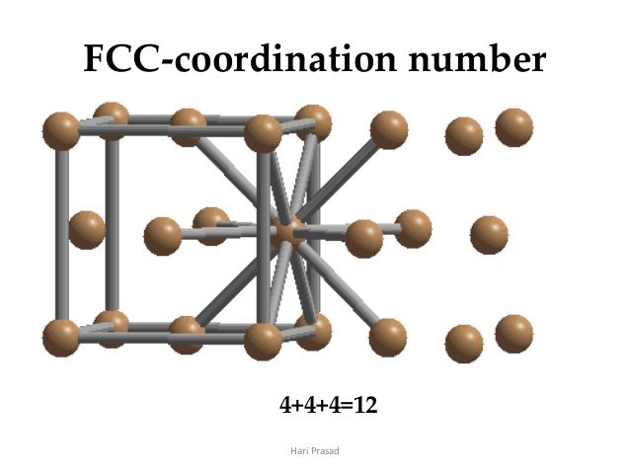

**Atomic packing factor (APF)** = Indicates how closely atoms are packed in a unit cell and is given by the ratio of volume of atoms in the unit cell and volume of the unit cell.

Atoms per unit cell =

8 * 1/8 + 6 * 1/2 = 1 + 3 = 4

## 3: Crystal structure of Mercury telluride (reproduced using XCrySDen) | Download Scientific DiagramPlanar density (PD)

= number of atoms in plane/area of the plane

Example Silicon:

(100):



(111):



(110):



## Summary coordination number, atoms/cell, APF, radius

**NOTE: Silicon unit cell length a = 5.43 $\dot{A}$ $\dot{A}$ = 0.1nm (Unit Angstrong)**

# Fundamentals of nanomaterials – Tutorial 1

Common **definition** Nanomaterial: At least one dimension is within 100nm.

**Synthesis nanomaterials**

Top-down approach: Bulk material is restructured (i.e. partially dismantled, machined, processed or deposited) (example microchips)

Bottom-up approach: Assembly from basic building blocks, such as molecules or nanoclusters (example soap & dirt, plasma vapour deposition, etc.)

**Classification of nanostructured materials**

**Compositional classification**

**Carbon based nanomaterials**

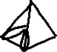

# Crystal structures and fundamentals - Lecture 3

## Silicon/diamond unit cell



Silicon has an FCC lattice structure with 4 additional atoms. The additional atoms are displaced by ¼*a with respect to the original FCC lattice.



Atoms per unit cell:

= 8*1/8 + 6*1/2 + 4*1 = 1 + 3 + 4 = 8



## Symmetry in crystals

## Crystal defects

**Point imperfections, Line imperfections, Surface imperfections, Volume imperfections**

“defect” or “imperfection” used to describe any deviation from the perfect periodic array of atoms in the crystal.

Point imperfections: vacancy defect (missing atom), substitutional impurity (foreign atom replaces), interstitial impurity (small atom occupies void space without disturbing parent atoms from regular sites)

# Quantum effects in nanomaterials – Tutorial 2

## Electron confinement

For 0-D nanomaterials the electrons are fully confined. For 3-D nanomaterials the electrons are fully delocalized. In 1-D and 2-D nanomaterials, electron confinement and delocalization coexist.

* Confined in nano dimension, delocalization in in non-nano dimension (i.e. along tube)

## Particle in the box

An electron is considered to exist inside of an infinitely deep potential well (region of negative energies), from which it cannot escape and is confined by the dimensions of the nanostructure.

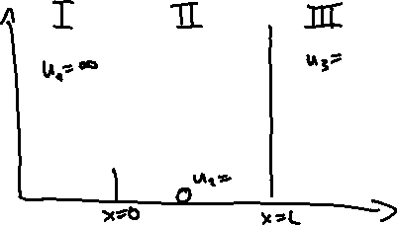

Schrödinger Equation General Solution

II:

V(x) = u2 = 0



Thus,

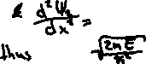

I & III:

V(x) = u1 = u3 = ∞



Thus, other terms negligible (= 0) in relation to ∞:



No wave function in region I & III. Thus, no probability of particle being in the regions.

Boundary Condition (BC): at x = 0 & x = L = 0

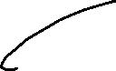

# From sand 2 silicon monocrystalline wafers + wafer yield – Lecture 4

## Silicon wafer manufacturing – 4 main steps

* Obtain **Metallurgical grade silicon (MGS)** in **electrode arc furnace**
  + Temperature 1500-2000°C
  + **SiO2 + 2C -> Si + 2CO**
  + Main impurities afterwards: Al & Fe (**~1000-6000 ppm**)
* Obtain **Electronic grade silicon (EGS)** by **Siemen’s process (fluidized bed reactor)**
  + Temperature 300°C
  + **Si**(s) + **3HCl**(g) -> **SiHCl3**(g) + **H2**(g) -> **Si**(s) **+ 3HCl**(g)
  + Main impurities afterwards: C & O (**100-1000ppb**) also **Polycrystalline**
* Diagram

  Description automatically generatedObtain **Single crystal silicon wafer** by a) **Czochralski technique (CZ)** orb) **Float zone technique**

1. CZ
   * Widely used, best method for large-scale low-defect wafers (up to **12”** possible)
   * Main components: furnace, crystal pulling mechanism, ambient control, control system
   * Temperature **1500°C**
   * **Small seed crystal** of desired orientation **grows** in molten silicon
   * **C & O introduced by support & crucible**
2. Diagram, schematic

   Description automatically generatedFloat Zone
   * Rarely used, **lower oxygen impurity** (no crucible)
   * **Polycrystalline EGS rod fused with single crystal Si seeds (des. orient.), then melted along rod**
   * **Max. 6”** wafer due to **defects caused by temperature profile**

* Further processing by cutting, polishing
  + Seed end & tang ends cut for uniform diameter
  + Primary flat (identify crystal orient.) & Secondary flat (identify dopant type & orient.) cut
  + Cutting into wafers (**diamond** **saw**)
  + Chemical etching & chemical mechanical **polishing for surface quality**

**NOTE: Wafer thickness (usually) in steps of 100um and size in steps of 2”**

## Yield calculation

**Die cost:**

cost-per-die = cost-per-wafer / (Ntotal*Y)

# Oxidation and Lithography – Lecture 6

## Thermal Oxidation

**Native oxide** = Silicon oxide grown with oxygen and the silicon of the wafer

Properties: Easy to grow, few defects, stable over time, good adhesion, prevention penetration of dopants, resistant to most chemicals, easy to etch/remove

**Applications:** Surface passivation, doping barrier, masking barrier, etch stop layer, sacrificial layer, insulation (prevention of cross-talk)

At **room temperature** oxidizes **0.5-10nm in 5 minutes**

### Dry Oxidation

* **Si**(s) + **O2**(g) -> **SiO2**(s)
* Temperature **900-1200°C**
* High quality, excellent insulator (use case: gate oxide in MOSFET)
* **Thin (5-500nm), usually <100nm**

### Wet Oxidation

* **Si**(s) + **2H2O**(g) -> **SiO2**(s) + **2H2**(g)
* Low quality (voids created by escaping H2), good insulator (use case: field oxide in MOSFET)
* Diagram, engineering drawing

  Description automatically generatedDiagram

  Description automatically generated**Thick (< 2.5um) with rate ~600nm/h** (OH diffuses quicker than O)
* Dummy bare wafers for uniform temperature profile
* **0.46 growth below original silicon wafer surface**

**Growth stages:**

Phase 1: Reaction rate based (linear growth)

Phase 2: Diffusion rate based (sqrt growth)

Note: Diffusion depends on plane. High PD (<111> for example) results in faster reaction due to more atoms being available at surface.

## Photoresists and Lithography

**Lithography** = mechanism to print 2-D patterns to a thin film layer on the wafer surface

**Masks** = Glass plates (soda lime or quartz glass) containing patterns (made with chrome)

**Photoresist** **(PR)** = light-sensitive polymer transferring pattern from mask to surface due to changes in chemical structure when exposed to UV light.

Components: Polymer: light-sensitive solubility

Solvent: makes thinner, removed during soft bake

Sensitizers: control chemical reaction during exposure

Additives: chemicals for additional features (dyes)

**Positive photoresist (PPR):**

Exposed regions will be removed (solubility in solvent (i.e., developer) of exposed regions is higher)

* Thickness: 0.5-10um

**Negative photoresist (NPR)**:

Exposed regions stay (solubility of exposed regions lower)

* Thickness: 1- 250um

**Note:**

* Thickness of **PR** should be **similar** to **thickness** of **material** to be removed. Important for selection of PPR or NPR
* After Lithography remaining PR is removed with **Acetone**

Lithography - Lecture 7

# MIDTERM CONTENT UNTIL HERE (2021)

## Diagram Description automatically generatedSpin Coating – Process to form thing films of PR on Si wafer

* Thickness: 0.1nm to 10um
* Advantages: simple process, wide range of thicknesses
* Disadvantages: shrinkage, less dense, more susceptible to chemical attack
* Physical properties:
  + PR properties: viscosity, drying characteristics, dispense volume
  + Spin properties: spin speed, acceleration, duration

Other methods: Spray coating, contact roller coating, dry film lamination

* For large areas and/or none-rigid substrates

## Soft bake

* After spin coating to remove excess solvent (otherwise sticking to mask plate)
* Temperature: 100-120°C
* Duration: 20 minutes

## Hard Bake

* After developing
* Temperature: 200-250°C
* Duration: 30 minutes

## Mask

* Types:
  + Glass-Chrome: High quality, fused quartz, written with electron beam
  + Plastic: Low resolution, cheap, fast, written with high-resolution printer

-

* Types of lithographic wafer exposure systems
  + **Contact Printing:** high resolution, mask wear, defect generation
  + **Proximity Printing:** less mask wear/contamination, lower resolution
  + **Projection Printing:** no mask wear/contamination, 4-5x magnification, expensive

* Shape

  Description automatically generatedPR profiles in practical

Depends on exposure dose, resist tone (PPR or NPR), resist absorption

Overall difficult to predict, experiments needed

**Feature size =** smallest feasible pattern in lithographic fabrication process *(min. length of MOS transistor channel between the drain and source)*

σ = feature size; k = Rayleigh constant; NA = numerical aperture of lens system, λ = wavelength (UV: 365nm), µ = refractive index (µwater > µair)

NA = µ*sin($θ$)

**Methods to reduce σ:**

* Reduce wavelength:
  + Extreme UV lithography (135nm), 128nm resolution
  + X-ray lithography (few nm), different mask needed (gold) with physical holes, which cannot be small enough
* Increase refractive index:
  + $θ$ is lens specific
  + µ can be increased by using water as medium between lense and wafer
* **Immersion Lithography**

**E-beam lithography:**

Advantages: High resolution (few nm wavelength of electron beams)

Disadvantages: Time consuming (direct write process)

**Double Patterning:**



Purple = SiO2, Orange = Si3N4, Green = Metal (Au)

Index repeating UV lithography steps (soft bake, lithography, development, hard bake) in first occurrence and refer in later repetitions to save time

**Note: Study process flow steps for double patterning**

# Silicon Anisotropic Wet Etching - Tutorial 5

**Wet etching =** Bulk micromachining process using liquid chemical solutions in contact with silicon

**Dry etching =** Bulk micormachining process using plasma or vapor phase etchants to remove material

Generally wet etching is cheaper

**Isotropic =** Etch rates in all directions are identical

**Anistropic =** Etch rate is orientation dependent

## A picture containing text, businesscard, envelope Description automatically generatedAnisotropic wet etching – Silicon

Typical etchant used: **Potassium hydroxide (KOH)**

In essence, **etch rate along <111> plane is significantly slower** than in <100> & <110> planes. The **angle between <100> and <111> is 54,7°**.

When only <111> plane is accessible by the etchant, the result is a **self-limiting stable profile** (before **transitional profile**). There are two types of resulting profiles, namely of a square mask is a **perfect point** (pyramid cavity), and the result of a rectangle mask is a **knife-edge**.

**Calculations:**

$T ≥\frac{t}{r_{<100>}}$ $with t=thickness \& r_{<100>}=etch rate$ is the time needed to etch through the whole wafer.

Case 1 (through-wafer hole): $w>2t/tan⁡(54.7°)$



To calculate depth after some time, solve time equation for **t**



To calculate **wB**: 2x = 2t / tan(54.7°)

w = 2x + wB

Case 2 (blind cavity): $w ≤2t/tan⁡(54.7°)$

To search for self-limited depth, solve equation above for **t**

# Etching – Lecture 8

**Etching =** selective removal of solid material through chemical (or physical) reaction.

## Wet etching

* Procedure in **Wet Etch Bench**
* **Reaction rate limited** by temperature or diffusion
* **Temperature** easier to **control**
* **Stirring** improves diffusion and avoids formation of bubbles on surface

 (given in exam)

R0 = rate constant, EA = activation energy, k = Boltzmann constant, T = temperature

**Etching Selectivity (Sfm) = Vf/Vm** with V = etch rate, m = mask, f = film

* Large selectivity is good

**Etching uniformity =** percentage variation of the etch rate across the wafer

**Etching anisotropy (A) = 1- RL/RV** with L,V = lateral, vertical etch rate

**Etch bias Etch undercut**

**Underetching Overetching**

**Etch stop layer**

can be used to slow etch rate, providing a stopping point of high absolute accuracy

Example boron doping for silicon etching

**Other etch stop layer**

Silicon-on-Insulator (SOI) wafer (has a buried oxide layer)

Silicon dioxide does not get etched easily by KOH

**Wet isotropic etching with HNA**

HNA = mixture of hydrofluoric acid (HF), nitric acid (HNO3), acetic acid (CH3COOH)

Nitric acid oxidizes silicon and hydrofluoric acid for dissolution of SiO2., acetic acid buffers solution

|  |  |  |  |
| --- | --- | --- | --- |
| Film | Masking Layer | Deposition Method (Mask) | Etchant (Film) |
| Silicon (Si) | Silicon dioxide (SiO2)  Silicon nitride (Si3N4) | Growth (dry/wet)  Deposition (CVD, PVD, PECVD/LPCVD) | KOH**1** (wet, anisotropic)  HNA**2** (wet, isotropic)  Dry etching (dry, anisotropic) |
| Silicon dioxide (SiO2) | Photoresist (PR)  (Silicon nitride (Si3N4)) | Spin Coating  “ See above “ | BHF**3** (wet, isotropic) |
| Au, Ag, Pt**4**, (Cr, FeO2) | Photoresist (PR) | Spin Coating | BHF (wet, isotropic) |
| Photoresist (PR) | N/A | N/A | PPR/NPR developer  Acetone |

**KOH1** = Potassium Hydroxide, **HNA2** = see above table, **BHF3** = Buffered hydrofluoric acid

**Au, Ag, Pt4** deposition with:

* Thermal evaporation (not for PR suitable due to temperature)
* Sputter or e-beam deposition

# Exercises

## Miller indices

## Yield calculation

# Cantilever production process flow methods

## Bulk micro machining



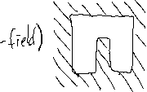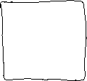

## Bulk surface machining - SiO2 anchor, Poly Si cantilever

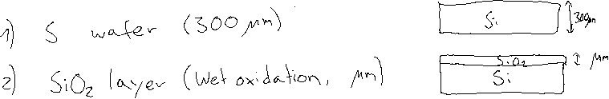

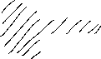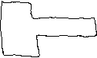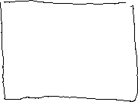

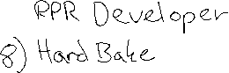

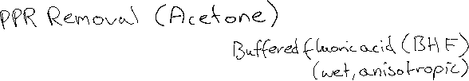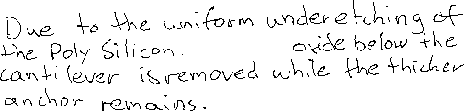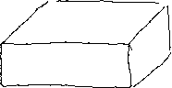

## Bulk surface machining – Poly Si anchor and cantilever

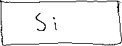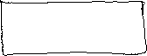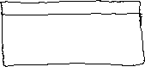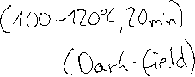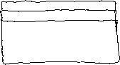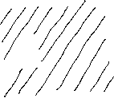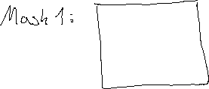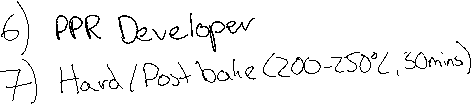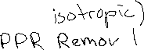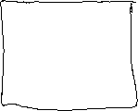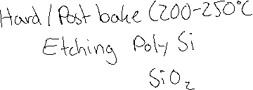

## Bulk micro machining – Silicon on Insulator (SOI) cantilever

