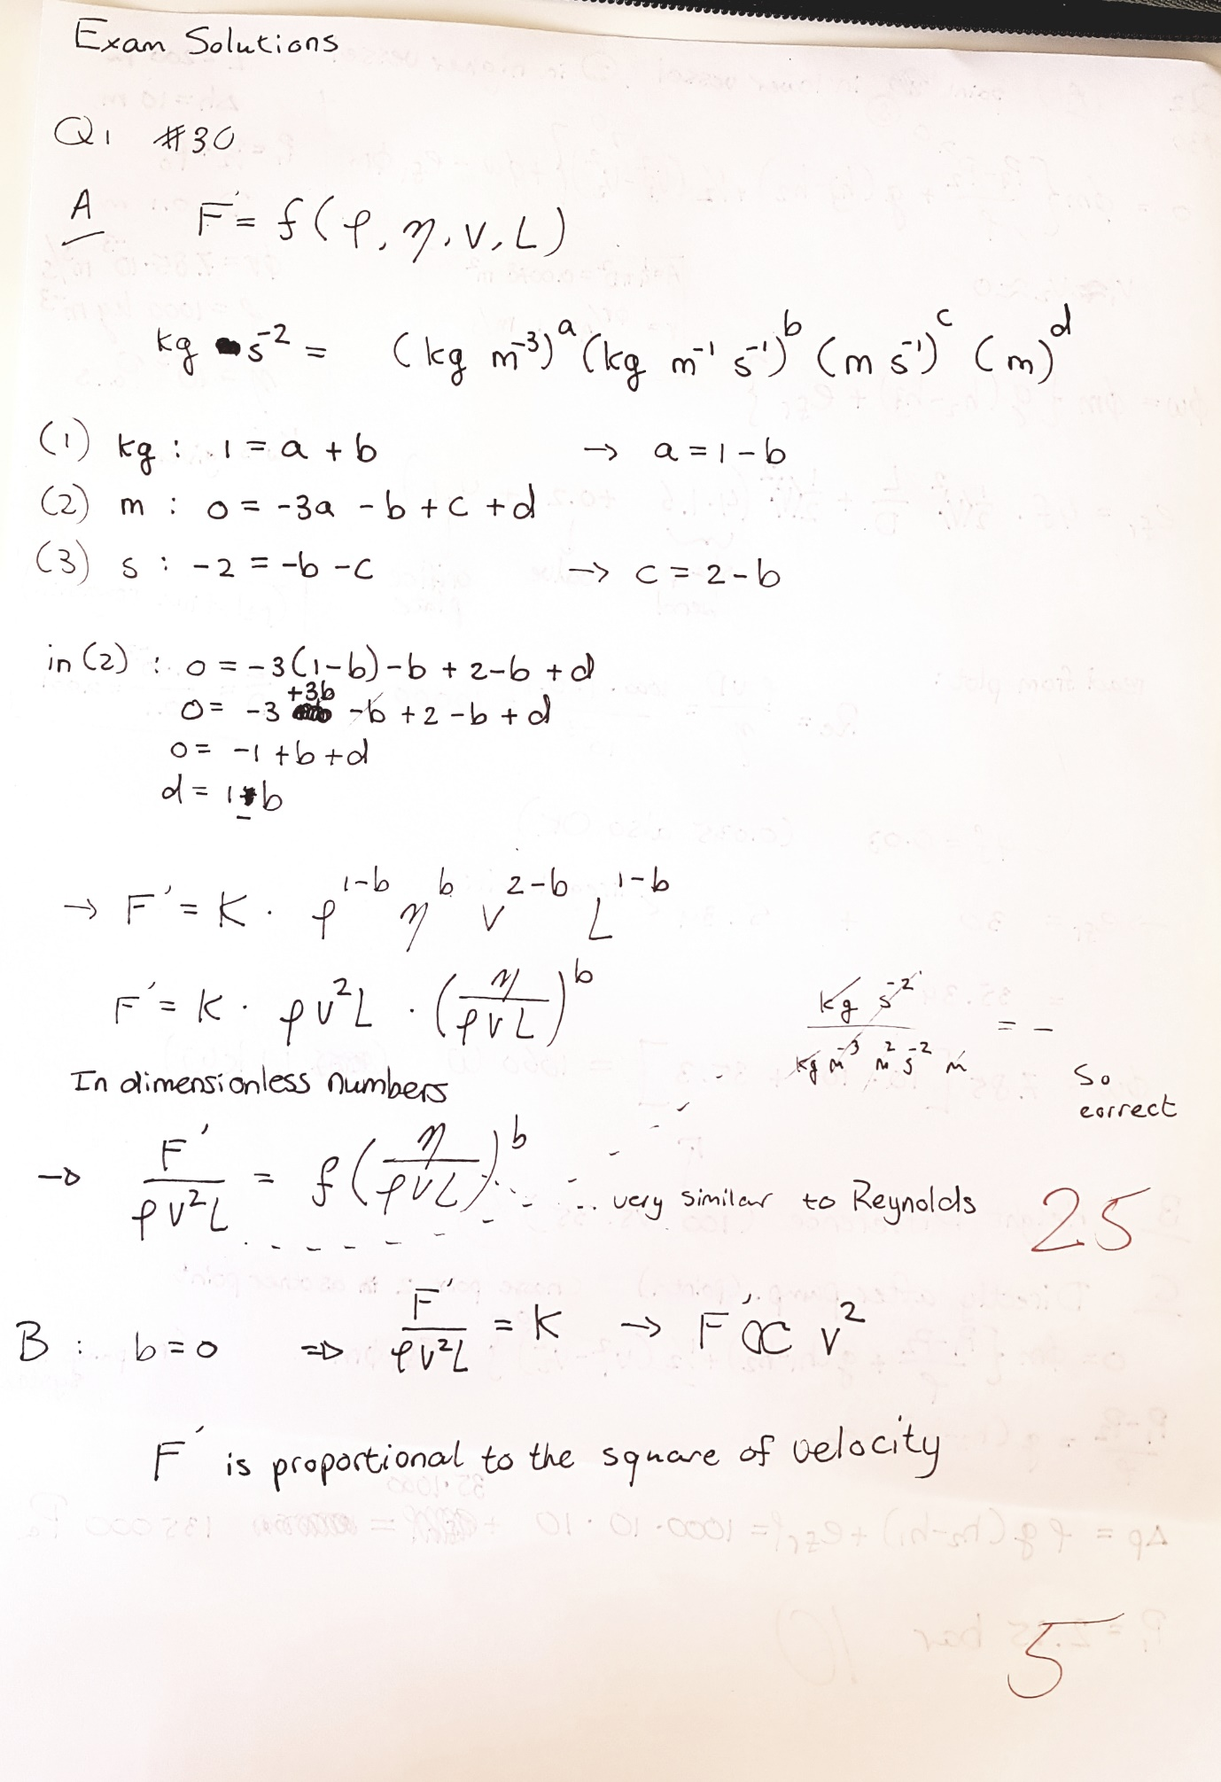

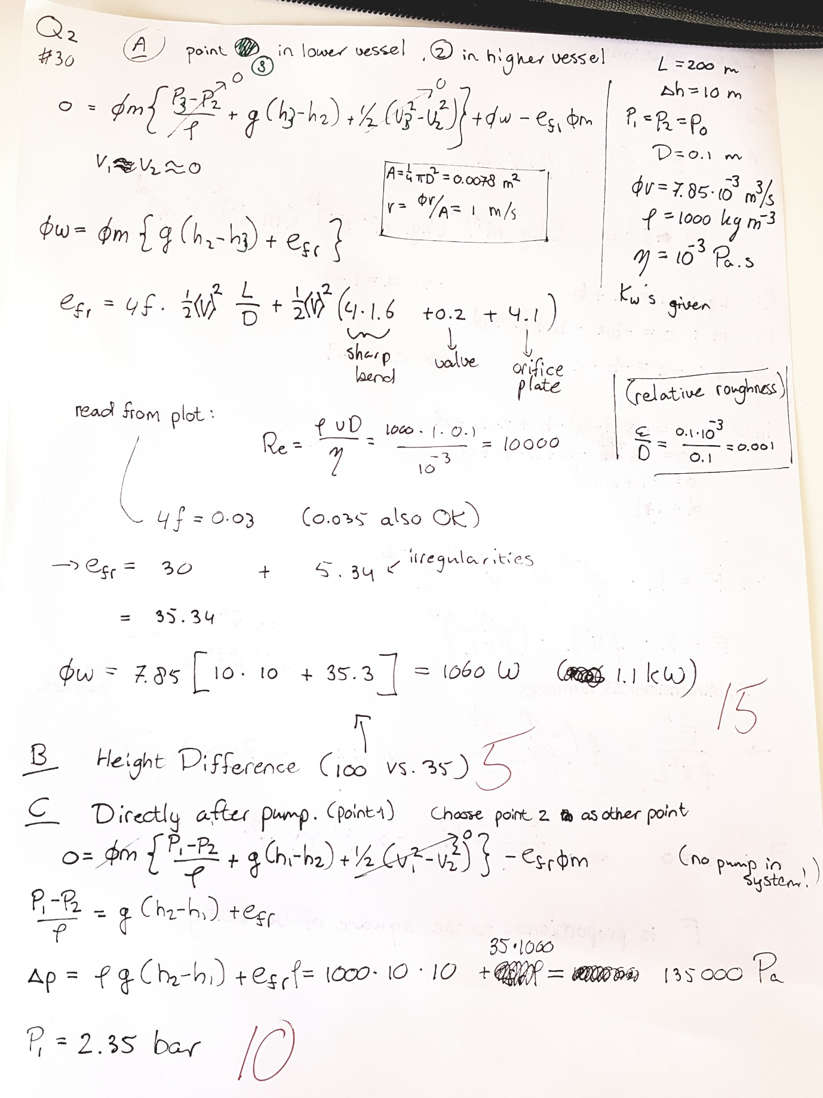
Note in Q2A: Reynolds = 10000 (not 100000). Results in a small difference in 4f from graph.
- Q2C: if point chosen in tank, then velocities do not cancel out. Minor difference, but also correct.

