MIDTERM EXAM Fluid Dynamics – RUG
September 14th 2020

Maximum # points for each question are indicated for every exercise

Grade= 1+ # points/10

Write on the first page:
- Your name
- Your student number

Write on every following page your student number

Don’t forget to write the dimensions in your answers (and of course dimensionless numbers have no dimensions.!!!)

(Sub)questions denoted with an * denote an extra level of difficulty and count only for 10% of the total grade of that exercise

Good luck, FP

This exam was written by Prof. Dr. F.Picchioni and reviewed by Prof. Dr. J.Yue.

Question 1 #30
The product of an extrusion process is a polymeric film that is immediately immersed, as soon as it exits the extruder, in a very large and deep liquid bath. The force per unit length F’ (kg*s⁻²) necessary to pull this film through the bath is a function of the density of the liquid ρ (kg*m⁻³), its viscosity η (kg*m⁻¹*s⁻¹), the linear velocity of the film v (m*s⁻¹) and its length L (m).
- By using dimensional analysis, derive an equation for F’ as function of the other parameters.
- By using a pilot scale installation and in certain particular conditions it is found that F’ is independent of the viscosity η. Under these conditions, what is the relationship between F’ and the velocity v?

Question 2 #30
Water is pumped in circular pipes from a low storage tank (3) to a higher storage tank (2), which is 10 m higher up. Both tanks are in contact with open atmosphere. The pump is positioned directly after the lower tank. Consider steady state conditions.
- Total pipe length: 200 m (between 1 and 2)
- Diameter: 10 cm
- Roughness: 0.1 mm
- Volumetric flow: 7.85 l/s
- Density: 1000 kg/m³
- Viscosity: 1 mPa.s
The K_{w} value for a sharp 90° bend is 1.6, for an open valve 0.2, and for the orifice plate 4.1.
- Calculate the power of the pump

- (*) To what contributes does the pump power contribute most? Friction losses or overcoming the height difference of 10 m? Explain your answer.

- Where do you expect the pressure to be the highest and what is the pressure at this point?

You might use the graph in Appendix 1
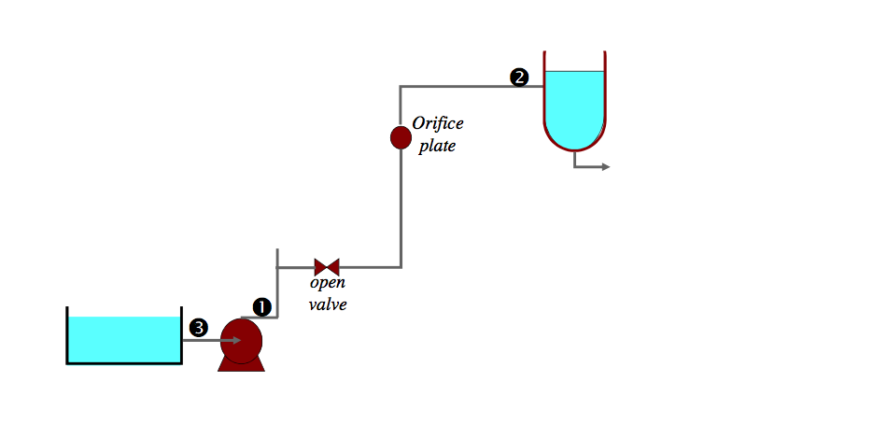

Question 3 #25.
In a new kind of nuclear reactor Uranium spheres are used as fuel. Because of the nuclear reaction, heat is produced in these spheres. This heat production (q=800 kW/m³) is uniform in these spheres with a diameter (2*R) of 20 cm. The surface of the spheres is at a constant temperature of 500K, implying steady state conditions.
- Derive an energy balance for a sphere with a radius r<R and write the differential equation describing the temperature within the sphere.
- After integration, calculate the temperature in the sphere as function of the distance from the center.
- What is the maximum temperature in the sphere?

Thermal conductivity of Uranium λ_{U} = 10 W/m K

Question 4 #5 (*)
Water rockets are relatively easy to make launching devices. They usually consist of an upside down soda bottle filled with water and pumped to a certain pressure with e.g. a bicycle pump. Once a hole in the cap (which is in the figure at the bottom of the upside down bottle) is opened, a water jet emerges which pushes the rocket into the air. This of course happens only if the pressure is high enough.
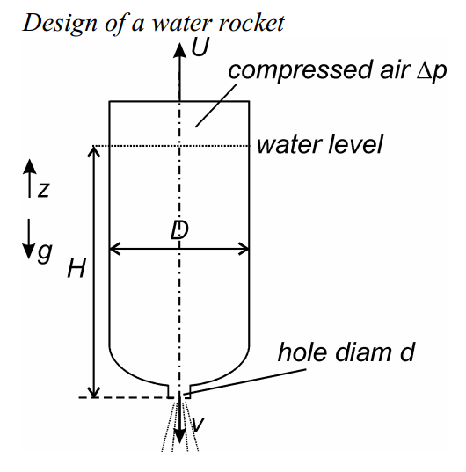
In this question we call v the downwards velocity of the water coming out of the bottle, U the upwards velocity of the bottle, H the level of water into the bottle before the hole is opened, D the diameter of the bottle, d the diameter of the hole and Δp pressure of the air in the bottle (after using the bicycle pump). Assume D = 15 cm, d = 1 cm and H = 30 cm, ρ = 10³ kg/m³. With these numerical values, we may assume that d << D, which simplifies the problem. Assume as well that the mass of the bottle is negligible compared to the mass of the water inside the bottle.
- Derive a formula for the velocity v as a function of Δp
- Write a momentum balance in the z direction which connects the velocity of the bottle U with the velocity of the outcoming water v. In this momentum balance some of the other parameters (D, d, H, ρ) are also involved
- Write a mass balance for the bottle to relate H and v
Combining the three balances, it is possible to derive what is the Δp needed to make sure that the water rocket really takes off.
- Calculate the required Δp. (you may use g = 10 m/s² and the assumption D >>d)

Appendix 1
Graphical relationship between friction factor (f) and Re.

ε is the roughness, and D is the diameter of the pipe.

