EXAM PTP1 – RUG
November 4th 2019

Maximum # points for each question are indicated for every exercise

Grade= 1+ # points/10

Write on the first page:
- Your name
- Your student number

Write on every following page your student number

Don’t forget to write the dimensions in your answers (and of course dimensionless numbers have no dimensions.!!!)

(Sub)questions denoted with an * denote an extra level of difficulty and count only for 10% of the total grade of that exercise

Good luck, FP

This exam was written and cross-reviewed by Prof. Dr. F.Picchioni, Dr. M.Cioffi, Prof. Dr. B. Jajawardana. Dr. J.Yue made an overall review.

Question 1 #25
An electrical glass plate is used to heat up 0.5 liter water. The power of the electrical plate is 1 Kilowatt (Watt is joule per second). The density of water is 10³ kg/m³, the specific heat of water is 4.2x10³ J/(kg·°C). We can assume that the initial temperature of water is 20°C, the surrounding temperature is also 20°C and that there are no heat losses.

- Derive a formula that describes how the water temperature changes with the time.

- Calculate how much time is required to heat up the water to 80°C.

We now still assume that there are no heat losses between the glass plate and the water, but we consider the heat losses between the beaker of water and the surroundings. The heat losses are proportional to the temperature difference between the water and the surroundings. The proportionality constant is equal to 5.3 W/°C.

- Write an energy balance to describe this situation.

- *Derive from your answer to question c) a formula from which you can calculate how much time is required to heat up the water to 80 °C. (N.B. you are not asked to calculate this time).

- After reaching 80°C we want to prevent the water from cooling down. How much energy per second must the electrical glass plate supply?

Question 2 #20
A purified liquid is continuously fed to a storage tank and siphoned off into a nearby river. The situation is such that this siphon is needed for the outflow from the tank. After the siphon, a pump is still required to transport the liquid to the river through a smooth circular tube with a diameter of 8.3 cm and a length of 1.2 km. The liquid has a density (ρ) of 1050 kg/m³, a viscosity (η) of
η = 1.0 x 10⁻³ Pa.s and a specific heat capacity (Cp) of 4.2 x 10³ J/(kg.K).
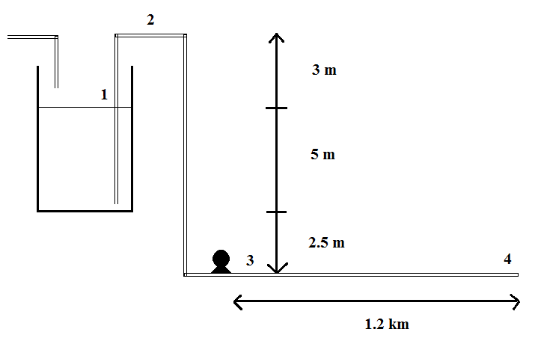
A. The initial pump is able reduce the pressure in the siphon to 0.4 bar (at point 2). Is this pump strong enough to activate the siphon?

When the siphon is activated and the liquid leaves the tank, the outflow should be equal to the inflow of 21.2 m³/hour. The total friction of the siphon can be simplified with a friction coefficient (Kw = 2.6).

B. The initial pump has a power of 750 W, is this enough to transport the liquid to the river with a flowrate of 21.2 m³/hour? What would you recommend?

Unfortunately, the tank sprung a leak. After 30 minutes the hole at the bottom of the tank was closed again. It was not necessary to shut down the plant, so the inflow was kept constant at 21.2 m³/hour. You may assume that the outflow of the tank via the siphon remained constant as well. The tank has an internal diameter of 7.4 m and the hole had a diameter of 2.9 cm.

C. Calculate the volume of liquid that has leaked out of the tank

Question 3 #25
Paints are emulsions, this meaning dispersions of a Iiquid into another. The stability of an emulsion is largely dependent on the average diameter (d, in m) of the dispersed phase. In turn, this diameter is a function of the energy per unit volume and time (ε, in kg m⁻¹ s⁻³) used to prepare the emulsion, the interfacial tension between the two liquids (γ, in kg s⁻²) and the density of the continuous phase (ρ, in kg m⁻³).
- How many dimensionless groups do you need to describe this problem?
- By using dimensional analysis, write an equation for d as function of ε, γ and ρ.

